Jan 04, 2021

▪

Approx. 22 min. read

8 Employee Engagement Statistics You Need to Know in 2021

5 Employee Communication Predictions for 2021 (And Beyond)

To get a better understanding of the current state of employee engagement, we laid out some statistics for those who love numbers.
Employee engagement is the key to building a successful business. But driving employee engagement doesn't come easy: worldwide, only 15% of employees are engaged with their work. So what went wrong?

Before deep diving into numbers, let's take a look at the definition of employee engagement and its importance in the workplace.

What Is Employee Engagement?

In today's fast-changing business environment, retaining top talent is a top challenge for most businesses.
According to new research of more than 600 US businesses with 50-500 employees, 63.3% of companies say retaining employees is actually harder than hiring them.

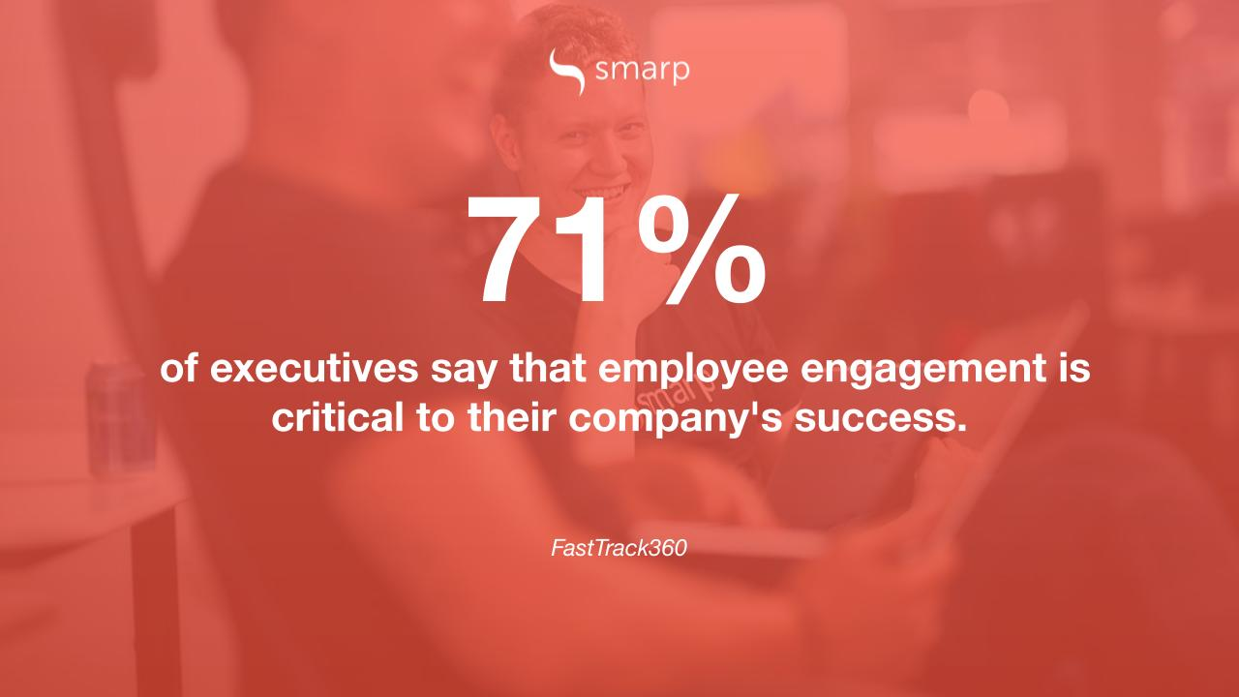
You're probably familiar with the "war for talent" concept. Basically, it means that because of the shortage of skills businesses are currently facing and employees' expectations (they don't just look at the benefits, they also take into account the company's values and the development opportunities you offer), it became more challenging for businesses to retain top talent.
Today, more than a third of workers are searching actively or casually for a job. As a result, US employers spend $2.9M per day looking for replacement workers. That's $1.1B per year. Ouch!
So, what does it take to retain top talent?
In a nutshell, if you want to stay on top of your game and win the "war for talent", you'll need to develop an effective employee engagement strategy.
But investing in employee engagement doesn't mean making your employees happy. Indeed, employee engagement does not mean employee happiness or employee satisfaction. All these concepts are connected, but they are not synonyms!
Think about it: even though your employees are happy with the employee benefits you offer or the work environment, that doesn't necessarily mean they are actually engaged with their jobs.
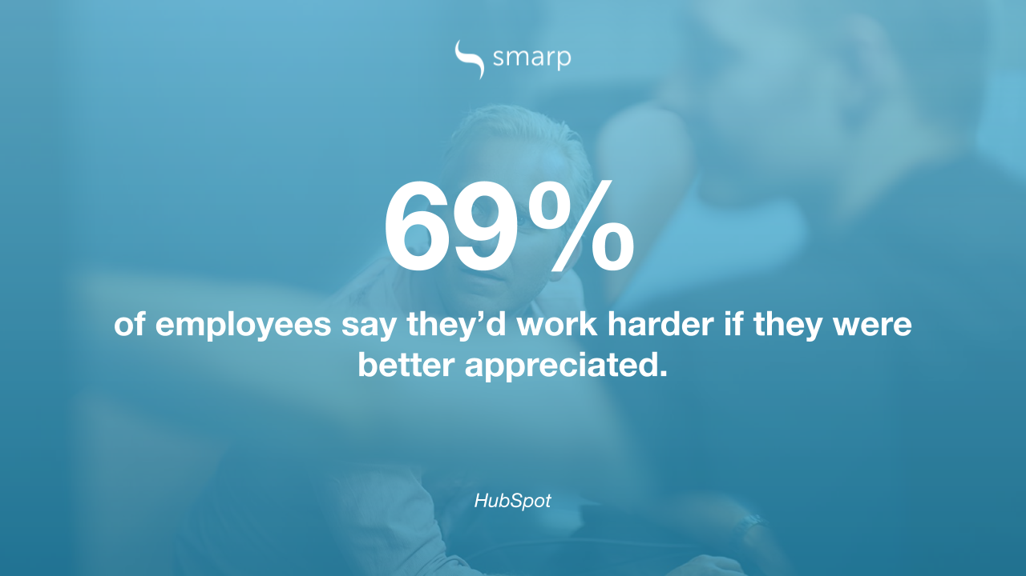
Not all experts and research companies have the same definition of employee engagement. For example:
- Quantum Workplace defines employee engagement as "the strength of the mental and emotional connection employees feel toward their places of work".
- According to Gallup, engaged employees are "those who are involved in, enthusiastic about and committed to their work and workplace".
- According to Willis Towers Watson, employee engagement is "employees' willingness and ability to contribute to company success".
- Aon Hewitt defines employee engagement as "the level of an employee's psychological investment in their organization."
So, what does employee engagement is?
In essence, employee engagement is the emotional commitment the employee has to the organization.
When employees feel engaged, they care about the company and they do their best work to achieve the company's goals.
When employees are engaged, their #1 objective is to contribute to the company's success. Employee engagement is not about employee benefits or bonuses, it's about being part of a successful business.
To learn more about the definition of employee engagement, check out the video below where Kevin Kruse, employee engagement expert and keynote speaker, explains what employee engagement is and most importantly, what it's not 👇

The Importance of Employee Engagement in the Workplace
As explained earlier, engaged employees do their best work to achieve the business's goals and they are willing to go the extra mile to contribute to the business's success.
Employee engagement has become one of the top priorities for most businesses and here's why:
- Employee engagement increases productivity in the workplace. Engaged employees outperform their peers that are not engaged. Overall, companies with high employee engagement are 21% more profitable.
- Employee engagement improves morale in the workplace.
- Employee engagement reduces absenteeism. In fact, a Gallup study shows that highly engaged workplaces saw 41% lower absenteeism.
- Engaged employees provide a better customer service.
- Low employee engagement is a costly problem! It costs businesses $4,129 on average to hire new talent, and around $986 to onboard the new hire. That means you lose over $5,000 each time an employee walks out the door, not to mention the unquantifiable cost of losing an experienced employee!
Engaged employees are more efficient and productive. But the majority of the workplace around the world isn’t engaged, and this has serious repercussions for business success!
Therefore, understanding the numbers behind employee engagement is crucial for improving employee engagement initiatives and tactics.
We laid down the most important employee engagement statistics for you to chew on (and remember to scroll all the way down to the bottom of this page to check out the infographic we made with these employee engagement stats 😊).

8 Employee Engagement Statistics You Need to Know
There are hundreds of interesting statistics on employee engagement.
To make things easier for you, we've picked top 8 stats you should definitively know about if you want to create an engaging company culture.
Are you ready? Let's dive in!

1. 85% of Employees Are Not Engaged in the Workplace
According to Gallup’s State of the Global Workplace, only 15 percent of employees are engaged in the workplace.
This means that the majority of workforce around the world are either viewing their workplace negatively or only doing the bare minimum to make it through the day, with little to no emotional attachment.
The study also reveals remarkable geographical differences - 33 percent of U.S employees are engaged at work - more than double the global average.
On the other hand, in Western Europe, only 10 percent of employees are engaged at work. The situation looks especially alarming in the U.K, where the amount of engaged employees is as low as 8 percent — and the number has been in steady decline for the past few years.
Related: Diversity and Inclusion Best Practices to Focus on in 2021

2. 81% of Employees Are Considering Leaving Their Jobs
According to a 2017 study, 81 percent of employees would consider leaving their jobs for the right offer, even if they wouldn't be looking for a job at the moment.
Changing jobs isn't all about the money, either, as 74 percent of younger employees would accept a pay cut for a chance to work at their ideal job, and 23 percent of those seeking a job wouldn't need a pay increase to take a new position.
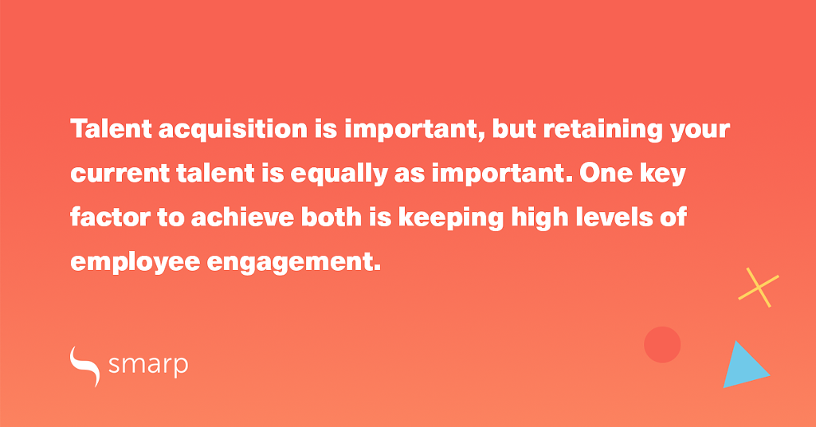In order to stay on the job, employees need to have relationships with other people in the workplace, and the work life needs to be balanced with their personal life.
Employees are also more likely to look for another job if their co-workers are doing so as well, so companies should be careful of a domino effect taking place in their workforce.

3. Low Employee Engagement Costs Companies $450-500 Billion Each Year
According to a study on workplace engagement in the U.S, disengaged employees cost organizations around $450-550 billion each year.
Disengaged workers take less responsibility and ownership of their attitude, behavior, and motivation, and drain overall productivity.
The study recommends that companies focus on encouraging personal agency and that they use tools to monitor and maintain personal engagement.
It is also important to connect the employees’ job to organizational missions, provide recognition and encourage collaboration.

4. Companies with Highly Engaged Workforce Are 21% More Profitable
Employee engagement isn't just about soft, intangible and feelings-based reviews about employee well-being.
Employee engagement has a very real impact on business success, and employee engagement should be considered a part of a business strategy.
According to Gallup’s meta-analysis, the business or work units that scored the highest on employee engagement showed 21 percent higher levels of profitability than units in the lowest quartile. Companies with highly engaged workforce also scored 17 percent higher on productivity.
Successful organizations focus on employee engagement by ensuring all employees have the best knowledge and tools available to perform their jobs as well as possible.
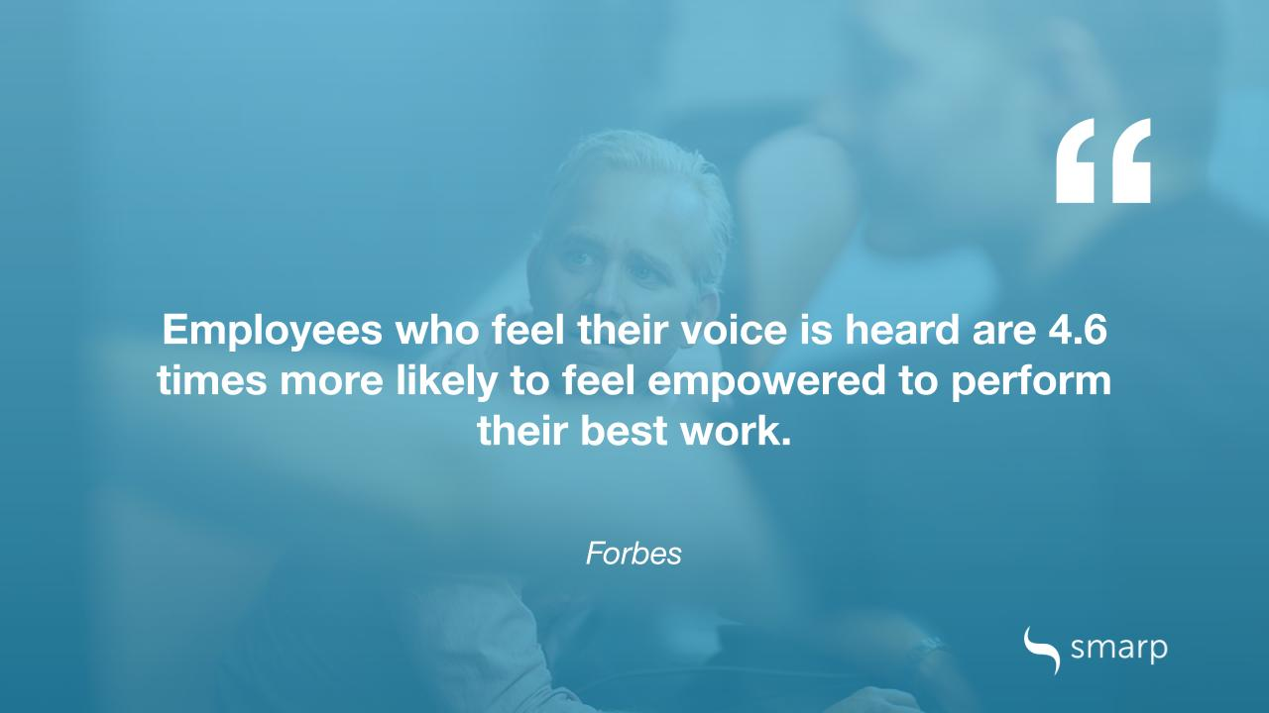
Managers in successful organizations also make sure all employees know what is expected of them, and support their employees’ professional development.
Effective communication leads to more productive employees and through this, to a more profitable workplace.
However, we're not there yet: a recent Interact/Harris Poll shows that 91% of the surveyed employees think that their leaders lack communication skills. What's more, almost 1 in 3 employees don’t trust their employers, according to the Edelman Trust Barometer. That's pretty alarming, isn't it?

5. Good Company Culture Increases Revenue by 4X
In a major long-term study, companies that had the best corporate cultures, that encouraged all-around leadership initiatives and that highly appreciated their employees, customers and owners grew 682 percent in revenue.
During the same period of evaluation — 11 years — companies without a thriving company culture grew only 166 percent in revenue. This means that a thriving company culture leads to more than four times higher revenue growth.
Company culture and employee engagement go hand in hand and a business focusing on employee engagement and improving their company will enjoy the benefits of increased revenue, increased productivity and increased employee engagement.
47 percent of people actively looking for a new job pinpoint company culture as the main reason for wanting to leave, so if you want to improve both employee retention and profitability, improving company culture should be one of your business priorities.
💡 To read about how to avoid mistakes in employee engagement, see this post: The 3 Biggest Mistakes You're Making in Employee Engagement

6. 1 in 3 Professionals Cite Boredom as Their Main Reason to Leave Their Jobs
According to a 2018 Korn Ferry Survey, the majority — 33 percent — of those changing jobs cite boredom and the need for new challenges as the top reason why they are leaving.
The second most common reason was the fact that the work culture didn't fit the employee or their values, with 24 percent choosing this as their main reason. The quest for a larger salary came fourth, with only 19 percent choosing it as their main reason for leaving.
Making sure employees have enough challenges and variation in their workday is one of the most important managerial tasks. Without the ability to develop themselves and learn, employees lose motivation and start to look elsewhere for a job.
Personal development is naturally good for the company as well, and as employees develop their skills and competencies, their work product becomes more refined and the company becomes more profitable.

7. 37% of Employees Consider Recognition Most Important
One study asked what would be the most important thing a manager or a company could do that would help the employee be successful and 37 percent — the majority — cited recognition as the most important method of support.
Other solutions lag far behind — 12 percent want more autonomy, 12 percent more inspiration, 7 percent more pay, 6 percent more training and 4 percent a promotion. This means over a third of the workforce need first and foremost to be recognized.
According to a survey on rewarding and recognition, 43 percent prefer to receive recognition privately on a one on one with a manager, 10 percent would prefer to receive recognition publicly in front of their peers, and 9 percent would prefer recognition privately, in written form.
Taking employees for granted is a surefire way to drop down the levels of employee engagement.
Instead, you need to make sure that your employees feel heard and valued. Recognition leads to increased motivation, a sense of pride and to increased self-confidence at work, which in turn increase employee initiatives and taking responsibility of one’s own work product.
A recent report shows that 84% of highly engaged employees were recognized the last time they went above and beyond at work compared to only 25% of actively disengaged employees.
A company that actively recognizes and rewards their employees is more likely to see increased levels of accountability, responsibility and leadership initiatives.
💡Now that we’re on the subject, be sure to check out this article as well: Top 15 Employee Motivation Tips and Benefits.

8. Only 29% of Employees Are Happy with Career Advancement Opportunities
According to SHRM's 2017 Employee Job Satisfaction and Engagement Report, only 29 percent of employees are "very satisfied" with current career advancement opportunities available to them in the organization they work for.
However, 41 percent consider this a very important factor to job satisfaction, so companies should pay close attention to making sure employees feel they can advance in their careers without leaving the company.
According to the SHRM study, 30 percent of employees considered career development opportunities for learning and personal growth in general very important, yet only 30 percent were happy with their current situation.
The chance for professional development on the job is especially important to the younger generations: according to a Gallup survey, up to 87 percent of Millennials consider development in a job important.
The importance of professional development to employee engagement is undeniable, and managers and HR personnel need to provide tools and resources to support their employees’ professional development.

Employee Engagement Stats [Infograhic]
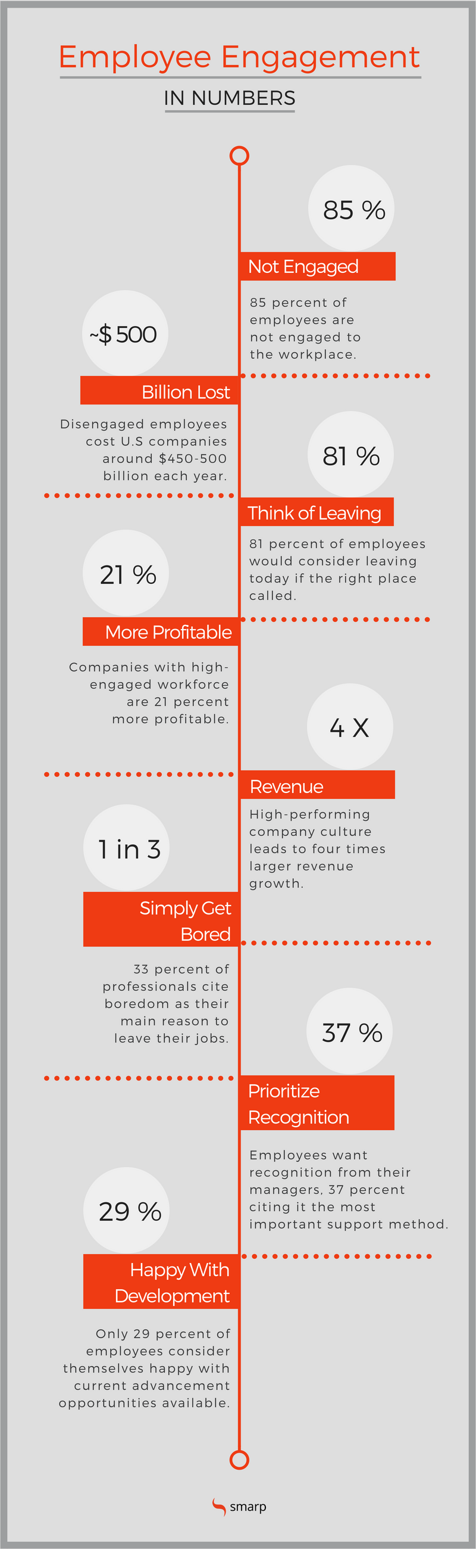

Has COVID-19 Impacted Employee Engagement?
Employees have been through though times in the past few months. The situation has been stressful for most of them.
Think about it: they had to adopt new ways of working and cope with sudden new work arrangements in no time. They had to cope with information overload, making it challenging for them to spot real and fake news. They also got concerned about their health and jobs as the number of layoffs skyrocketed during the pandemic.
💡Read on: Remote Work: 20 Ways to Engage and Connect with Your Remote Employees
Now, the question is: has COVID-19 impacted the way employees feel about their jobs and companies? Do they feel more motivated and engaged or has the pandemic had a negative impact on their engagement levels?
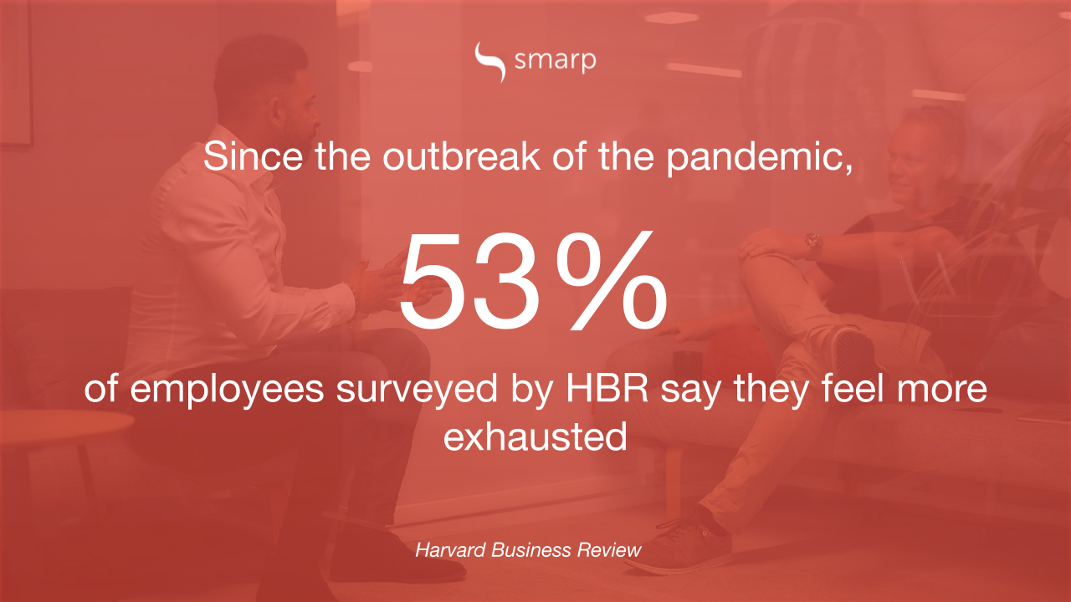Those are though questions as the way employees feel depends on the way their companies have handled the situation.
However, some newly released statistics can help us get a better understanding of how employee engagement has been affected by the pandemic:
- 88% of organizations have encouraged or required employees to work from home, regardless of whether or not they showed coronavirus-related symptoms (Gartner)
- While 60% of employers have increased employee listening efforts, few are using formal listening approaches. Indeed, just 31% conduct employee surveys and 13% conduct focus groups (Willis Towers Watson)
- Only 47% of employers have the capacities or processes in place to meet a crisis with the best possible outcome (Chief Executive)
- A survey run in the UK during the pandemic showed that 73% of the respondents believed they were more efficient when working from home (Statistica)
- The top advantages of working from home include a lack of commute (47% of respondents) and a more flexible schedule (43%) (the new stack)
- 22% of remote employees say that they struggle to unplug after work (Buffer)
- A full week of virtual meetings leaves 38% of employees feeling exhausted while 30% felt stressed (Forbes)
- Since the outbreak of the pandemic, 75% of employees say they feel more socially isolated, 57% are feeling greater anxiety, and 53% say they feel more emotionally exhausted (Harvard Business Review)
- By early April, about 45% of workers said they were burned out, according to a survey of 1,001 U.S. employees by Eagle Hill Consulting (Bloomberg)
- 85% of employees say they’re most motivated when management offers regular updates on company news (Trade Press Services)
- Only 42% of employees strongly agree that leadership is effectively leading their organization through the crisis (Perceptyx)
- When employees are extremely satisfied with communications about the company’s response to coronavirus, 96% of them believe that their employer really puts their safety first. When communication is poor, only 30% of them believe so (Perceptyx)
- During the pandemic, employees worked up to three hours more each day (Bloomberg)
- 20% of remote employees say that they lack a sense of belonging and sometimes feel lonely (Forbes)
- Employees who say their manager is not good at communicating are 23% more likely to experience mental health declines (Harvard Business Review)
- 86% of employees say they feel the need to prove to bosses they are working hard and deserve to keep their jobs (Cityam)
- 16% of employers are using technologies more frequently to monitor their employees through methods such as virtual clocking in and out, tracking work computer usage, and monitoring employee emails or internal communications/chat (Gartner)
- 45% of adults are reporting that anxiety and stress related to COVID-19 has had a negative impact on their mental health (The National Law Review)
- When it comes to the pandemic, more than 90% of employees said they wanted at least weekly communication from their company; 29% said they prefer daily communication (Harvard Business Review)
- Gallup Panel data from June 8-14 show that U.S. employees and managers are about 20% less likely than they were in May 2020 to strongly agree that they feel well prepared to do their job, their employer has communicated a clear plan of action in response to COVID-19, their immediate supervisor keeps them informed about what's going on in their organization, and their organization cares about their overall wellbeing (Gallup)
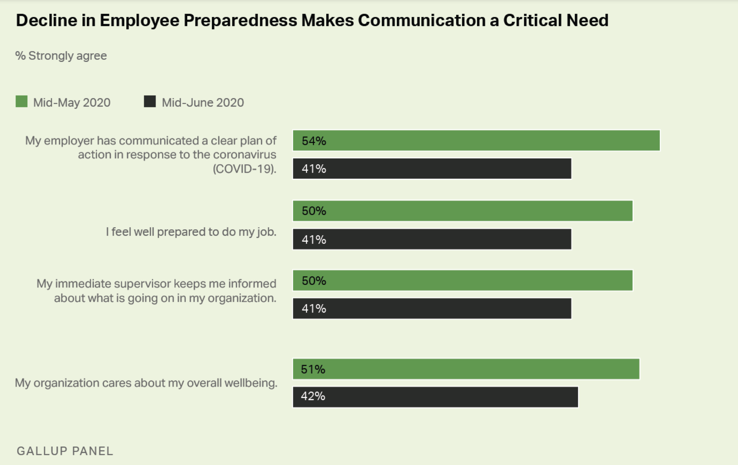

The Role of Internal Communications in Employee Engagement
The very first thing you need to take a look at when it comes to improving employee engagement is your internal communication.
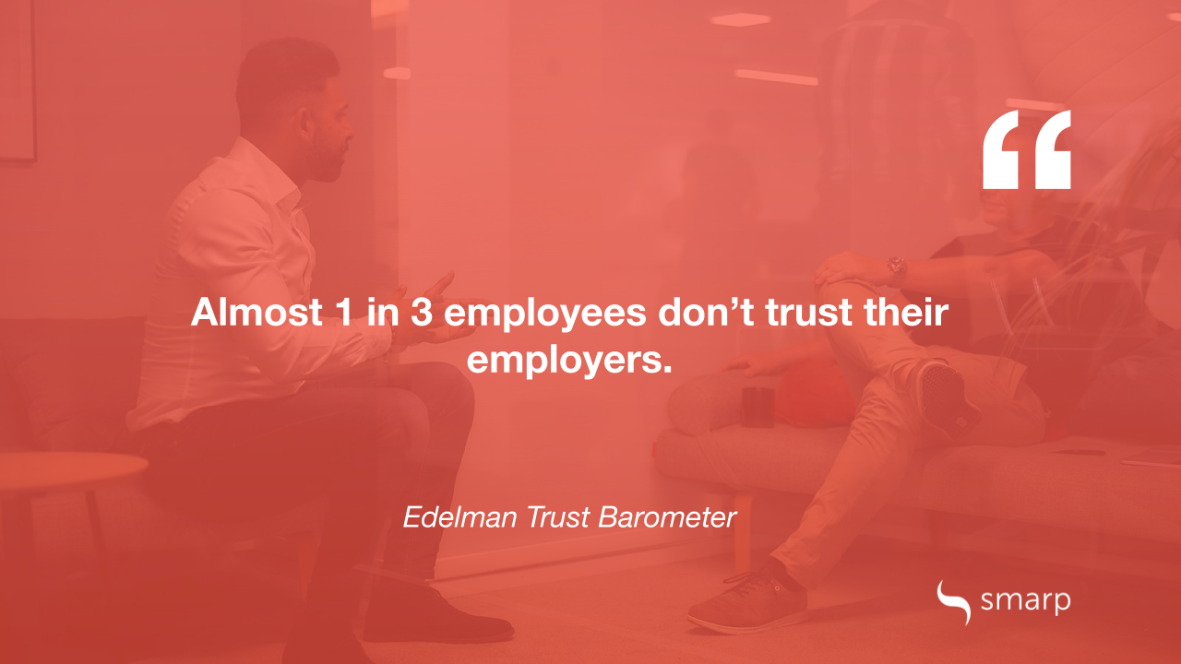Indeed, your internal communication strategy is one of the key drivers of employee engagement.
When a company has a great internal communications strategy in place, employees feel more informed, secure and motivated to achieve the company's goals.
💡Are you wondering what communication skills you need to develop to improve employee engagement at your workplace? Check out the video below and learn more about the top communication skills you can't ignore:

What's more, effective internal communications lower frustration in the workplace, which is strongly connected with employee engagement.
Think about it: the typical knowledge worker spends 2.5 hours a day searching for information. When key information is missing, employees need to look for it by themselves. They end up browsing their Intranets and G-Drives for hours and calling their colleagues for help.
At the end of the end, poor internal communication leads to employee frustration and lower productivity in the workplace. So, before you start planning your next employee engagement strategy, start with your internal communication!
What's next? Download the eBook “10 Principles of Modern Employee Communications” where we share tips & best practices for successfully communicating with your employees in today's digital age.
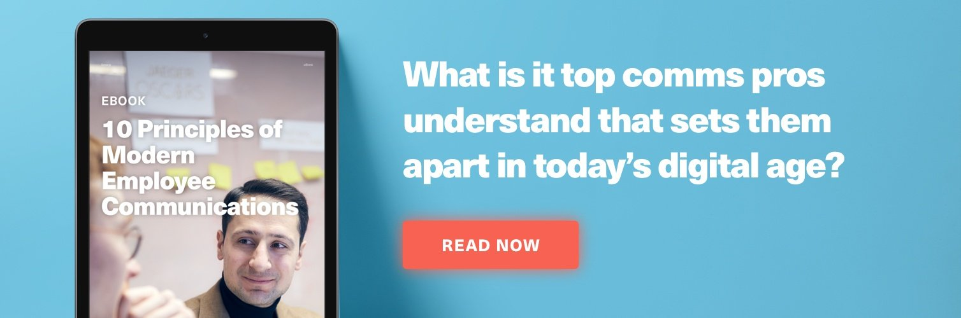
FACEBOOK
TWITTER
LINKEDIN

WRITTEN BY
Valène Jouany & Mia Mäkipää

